# Current Advert Campaigns

## analysis

### WWF (example):

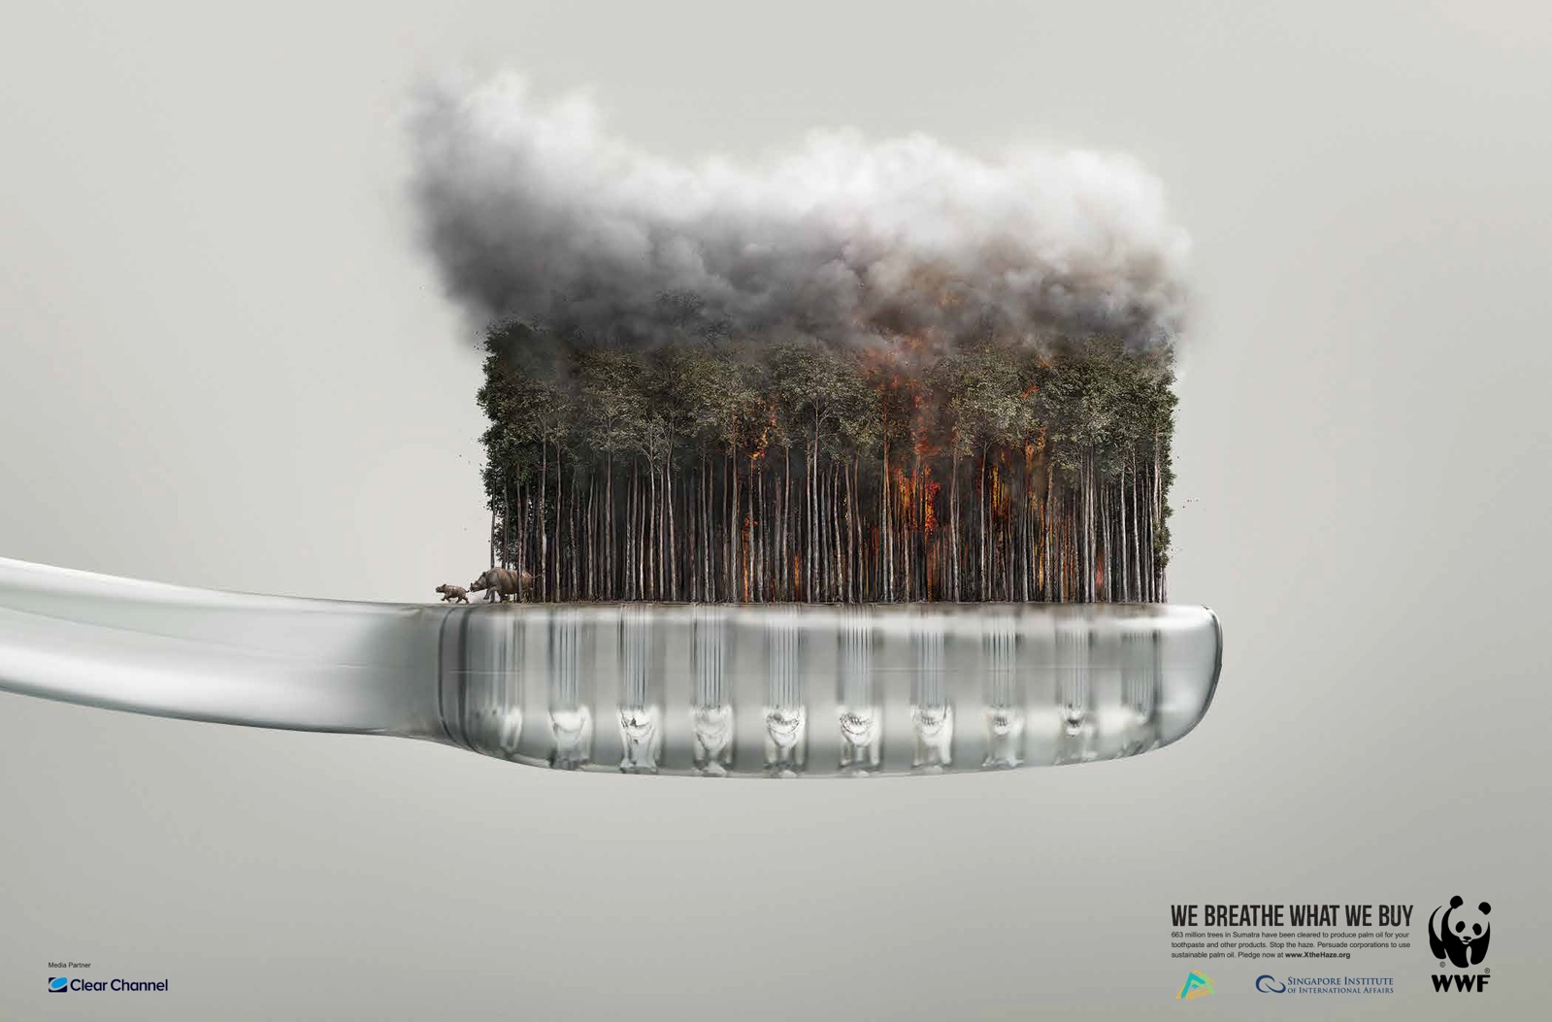

This successful poster uses techniques such as shock and an infeasible scene to draw the audience’s attention. The use of a familiar household object such as the disposable tooth brush helps make the poster relevant to people and make the audience feel more responsible for problem they are describing as generally people tend to separate themselves from the damage humans, generally, are causing. We hope to do this in our app by working out statistics based upon the user’s data which will display information such as how much ice they, personally, have melted this year or how many polar bears the have killed.

1. What attracts attention?
2. What do you like about it?
3. Is there anything important or relevant to the campaign in the colour/layout they have chosen?
4. A device that works well in the advert.
5. How we could use that in our app.